|  |
| --- |
| ZNA SPO Migration – Direct Markets Reinsurance Accounting Custom Site - Requirements Document  March,2021 |

**Document information**

**History**

|  |  |  |  |
| --- | --- | --- | --- |
| **Date** | **Version** | **Revision Author(s)** | **Notes** |
| 3/22/2021 | 1.0 | Troy Hostetter | Initial Draft |
| 3/29/2021 | 2.0 | Sushma Kollareddy | Modified based on SO review comments |
|  |  |  |  |
|  |  |  |  |
|  |  |  |  |

**Reviewers and Approvers**

|  |  |  |  |
| --- | --- | --- | --- |
| **Date** | **Version** | **Reviewer/Approver (role)** | **Note** *(State if document was reviewed or approved. Add additional notes if required)* |
| 04/02/2021 | 2.0 | Stacy Dvorak | Email Signoff |
|  |  |  |  |
|  |  |  |  |
|  |  |  |  |
|  |  |  |  |

**Table of contents**

1. Purpose 4

2. Scope 4

2.1 Share Point Site Information 4

2.2 Current State 4

2.3 Desired Future State 4

3. Exclusions, Assumptions and Limitations 4

4. Requirements 4

4.1 Functional Requirements 4

4.2 Non-Functional Requirements 14

5. Design Details 14

6. Terms and Definitions 14

7. Supporting References 15

# Purpose

The purpose of this document is to define the requirements for a selected Share Point site as part of ZNA Custom Share Point Online Migration project.

# Scope

## Share Point Site Information

|  |  |
| --- | --- |
| Site Title (Code) | Direct Markets Reinsurance Accounting (DMRA) |
| Customized Site URL | <https://finance.znaintranet.zurichna.com/teamsite/00739> |

## Current State

The current site is a ZNA on-premises custom SharePoint 2013 site. The current site has 3 forms (Create, Edit and Approve) and 2 workflows associated with F & I Ops Approval List which allows user to input data on the list and help with the email and approval process of the list entries.

|  |  |  |
| --- | --- | --- |
| Site Objects | Name | URL |
| Form – 1 | Create Distribution Request | https://finance.znaintranet.zurichna.com/teamsite/00739/Lists/F%20%20I%20Ops%20Approval/NewItemForm.aspx |
| Form – 2 | Edit Distribution Request | https://finance.znaintranet.zurichna.com/teamsite/00739/Lists/F%20%20I%20Ops%20Approval/EditItemForm.aspx?ID=1704 |
| Form – 3 | Approve Distribution Request | https://finance.znaintranet.zurichna.com/teamsite/00739/Lists/F%20%20I%20Ops%20Approval/ApproversEditForm.aspx?ID=1704 |
| List – 1 | F & I Ops Approval | https://finance.znaintranet.zurichna.com/teamsite/00739/_layouts/15/listedit.aspx?List=d8dd5a8b%2D5006%2D4b3b%2Db016%2D147a9e4a847a |
| Workflow – 1 | FI Ops Approval Workflow | **See Supporting References Section** |
| Workflow – 2 | FI Ops Reminder Workflow | **See Supporting References Section** |

## Desired Future State

The current ZNA on-premises custom SharePoint 2013 site is to be migrated to SharePoint Online cloud environment. The detailed enhancements / replacements / replications that are to be created in the target environment to reproduce the existing business functionality.

# Exclusions, Assumptions and Limitations

* All customizations will be delivered with out-of-the-box SharePoint Online functionality, Power Automate, Microsoft Forms, Power Apps, or a combination of any of these technologies.
* The migrated SPO site and the site objects will have the same access permissions as that of the source on-premises SP site.
* Workflow history and associated tasks will not be migrated.

# Requirements

## Functional Requirements

|  |  |
| --- | --- |
| Rqmt # | Requirement Description |
| DMRA_FR_001 | Recreate the form using Power Apps. This is the Create View. Show only these fields when an item is created.    When a record is saved, update the following fields:  **Requestor:** The person who submitted the form. |
| DMRA_FR_002 | Combo box ‘Type of Distribution’ with values on the form |
| DMRA_FR_002(a) | On the SPO site, below additional values has to be available in ‘Type of Distribution’ Combo box:   * Accountant/Attorney Fees * Cession Settlement * Interplan Transfer |
| DMRA_FR_003 | Use the existing Bank Names list for the lookup on the form. |
| DMRA_FR_004 | Create a custom lookup list for the Status values |
| DMRA_FR_004(a) | On the SPO site, re-name the ‘Returned’ status value to ‘Back to Requestor’ |
| DMRA_FR_005 | Set the default value when the form is submitted to “Submitted” |
| DMRA_FR_006 | Add the additional fields to the Power App Edit view of the form. Fields include Reviewer Comments, Requestor, any Attachments to the list item, the current version of the list item, the item created datetime stamp, the item created user name, the last modified datetime stamp, and the last modified user name. All fields may be updated. |
| DMRA_FR_006(a) | In the Edit view of the form - Add a ‘Link to existing Item’ dropdown field to lookup the existing items from the ‘F & I Ops Approval’ list, with the list item ‘ID’ as the first value, ‘Title’ as the second, ‘Plan No’ as the third, and ‘Total Amount’ as the fourth.  Display this field after/next the ‘Reviewer Comments field. |
| DMRA_FR_007 | Once the Create form is submitted, a Power Automate flow will notify, via email, everyone in the SharePoint Security Group “F & I” Ops Reviews that a review has been submitted. The contents of the email are:  **Email Format to Reviewer for Submitted Item**    When the status is Submitted, the flow will update the RequestID to the current item ID.  When the status is Submitted, the flow will update the current item with the following data: |
| DMRA_FR_008 | Reviewers then are able to view and edit the form, and set the status to Reviewed or Back to Requestor. If the status is set to Reviewed, a flow will run and notify the Approver(s) that an item has been Reviewed and is ready for approval. If the status is set to Back to Requestor, a flow will run and notify the Requestor that the item has been Back to Requestor.  **Email Format to Approver(s) for Reviewed Item**    When the item is set to Reviewed, set the following values in the current item:    **Email Format to Requestor for Returned Item** |
| DMRA_FR_009 | Below Approval form is used by the approvers to approve the item:    If the item has not been approved yet, set the Approver 1 and Approver 2 Signoff people picker fields to the corresponding user accounts in the Bank Name list for the selected Bank on the item  If the selected Bank has only one Approver name then only ‘Approver 1’ field is populated and ‘Approver 1 Sign Off’ is needed. |
| DMRA_FR_010 | On the SPO site, make the ‘Status’ field read only to Approver 1 and Approver 2. The field should be changed to Approved / Back to Reviewer based on yes/no values selected in Approver 1 and 2 Sign Off fields.  If the bank has only one approver (approver 1) and   * Selected ‘Yes’ in Approver 1 Sign Off field then status is set to ‘Approved’ * Selected ‘No’ in Approver 1 Sign Off field then status is set to ‘Back to Reviewer’   If the bank has two approvers (approver 1 and approver 2) and   * Both selected ‘Yes’ in Approver 1 Sign Off and Approver 2 Sign Off fields then status is set to ‘Approved’ * Atleast one selecetd ‘No’ in Approver 1 Sign Off or Approver 2 Sign Off fields then status is set to ‘Back to Reviewer’ * One (Approver 1 or Approver 2) selected ‘Yes’ in Approver 1 Sign Off or Approver 2 Sign Off fields and other did not make any action yet then status is still in ‘Reviewed’ |
| DMRA_FR_011 | Display the below highlighted two additional fields below/next to ‘Comments’ field of Approval form when ‘Settlement’ value is selected in ‘Type of Distribution’ field. |
| DMRA_FR_012 | Once the item has been updated to Approved status, the flow will send an email to the Reviewer.  **Email Format to Reviewer** **for Approved Item**    The flow will also set these values when the item is Approved |
| DMRA_FR_013 | If an item has been set to ’Back to Reviewer’, the flow will send the following email to the Reviewers:    The flow will also set these item values |
| DMRA_FR_014 | If the Type of Distribution is “Settlement” and the Status of the Item is “Approved,” send the following email to the YSV20197 distribution group. |
| DMRA_FR_015 | If the reviewer changes the status of the item to ‘Completed’ from Edit form, the flow will set the following values in the item: |
| DMRA_FR_016 | After 48 hours of being in “Reviewed” status, a flow will start sending daily reminder email(s) to the Approver(s) requesting to Sign Off an item. The flow will continue until the item is maked ‘Approved’  If Approver 1 Signed Off an item and only Approver 2 is pending then the flow will send reminder email notifications only to Approver 2 and vice-versa. |

## Non-Functional Requirements

No identified Non-Functional Requirements**ANN**

# Design Details

|  |  |
| --- | --- |
| 1 | Develop a Create, Update, and Approve Request Power App form. The New button should launch the Create form and the Edit link should launch the Update form.  The Edit form should check the current user and the current status of the item. If the current user is one of the users in the Bank Name list AND the current status is Reviewed, display the Approval Format form, otherwise display the Edit form. This means the only way to Approve a Request is if it has been Reviewed by a Reviewer. |
| 2 | All the input field details (field names, description, field values) for Create/Edit/Approved Distribution Request forms should be as noted in the attached document |
| 3 | The FI OPS Approval Power Automate flow will handle all of the status changes on the Request Item. It should be listening for either Create or Update actions on the List Item |
| 4 | The FI OPS Approval Power Automate, if it ever updates the list item, should use the System Update process. The Modified By user account should never be the Power Automate account. It should be the account that initiated the Flow. |
| 5 | The FI Ops Reminder Power Automate will run every day against all Requests that are not Completed. It should be able to be manually started. |

# Terms and Definitions

|  |  |
| --- | --- |
| Term or Acronym | Definition |
| OOTB | Out-of-the-box |
| PDF | Portable Document Format |
| SP | Share Point |
| SPO | Share Point Online |
| ZNA | Zurich North America |

# Supporting References

There are no available supporting refences for this document. The document is based on the interview with the SP Site Owners.

**FI Opps Approval Workflow Details**

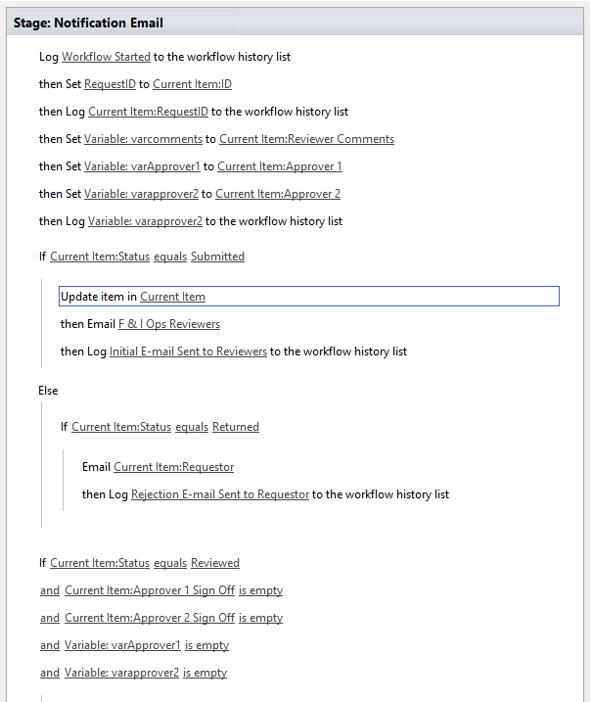

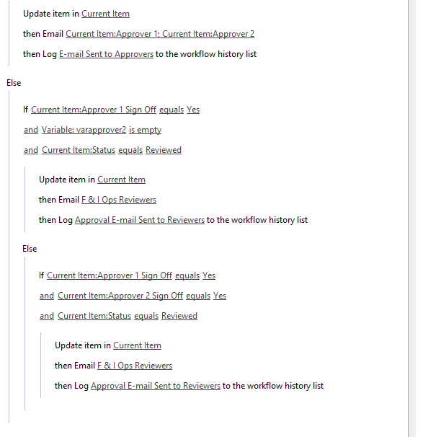

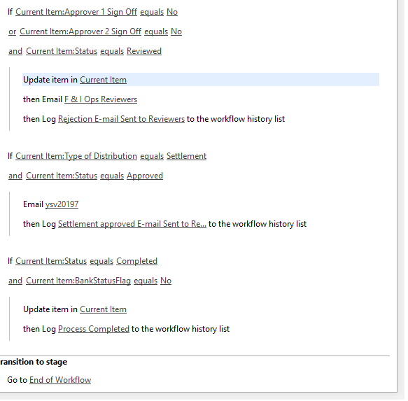

**FI Ops Reminder Workflow**

